- Install Matplotlib in your Python environment and create a simple line plot showing the number of daily steps you took over the last 7 days. Save the chart as steps_lineplot.png.
pip install matplotlib
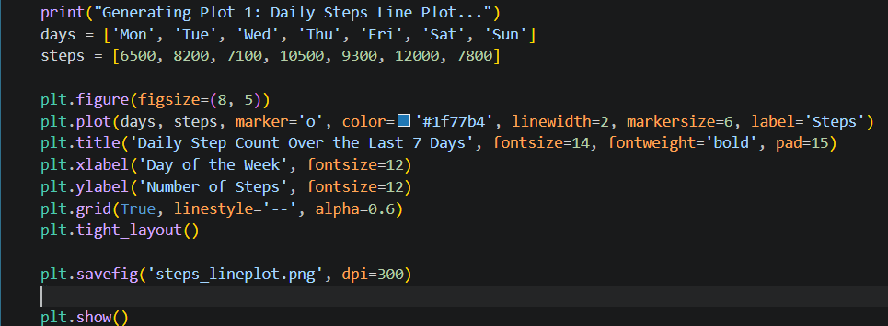
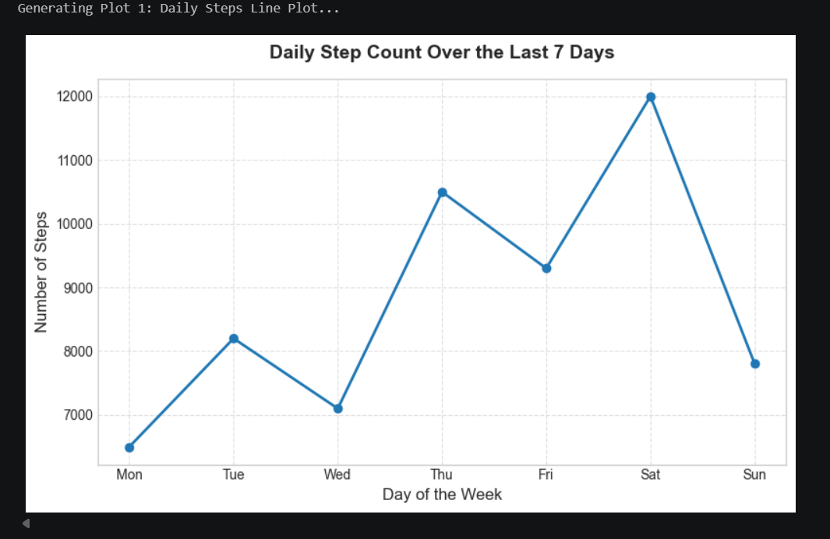

- Using Matplotlib, create a scatter plot of 10 restaurants from your city with their Zomato ratings on the x-axis and average meal price on the y-axis. Add axis labels and a title to the chart.
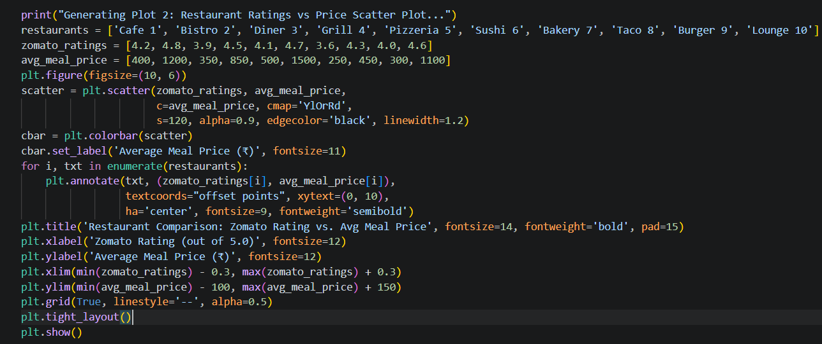
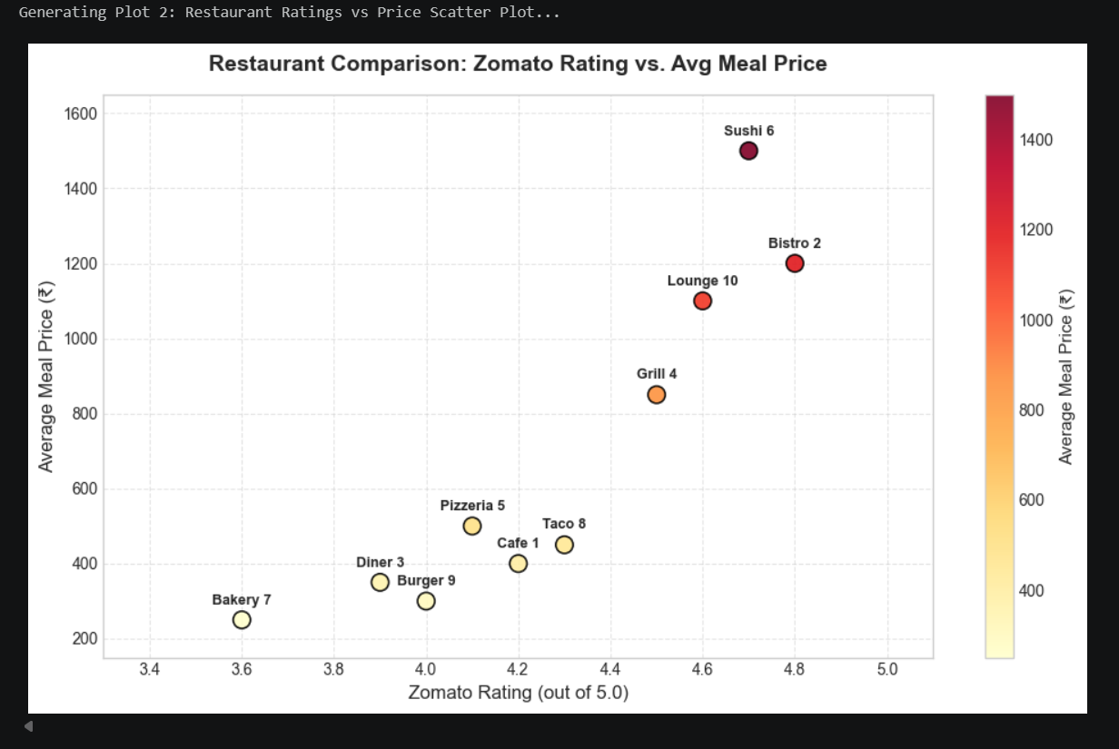

- Build a bar chart that shows the number of orders you or your friends placed on Swiggy, Zomato, and Domino’s in the last month. Use different colors for each bar and add a legend.
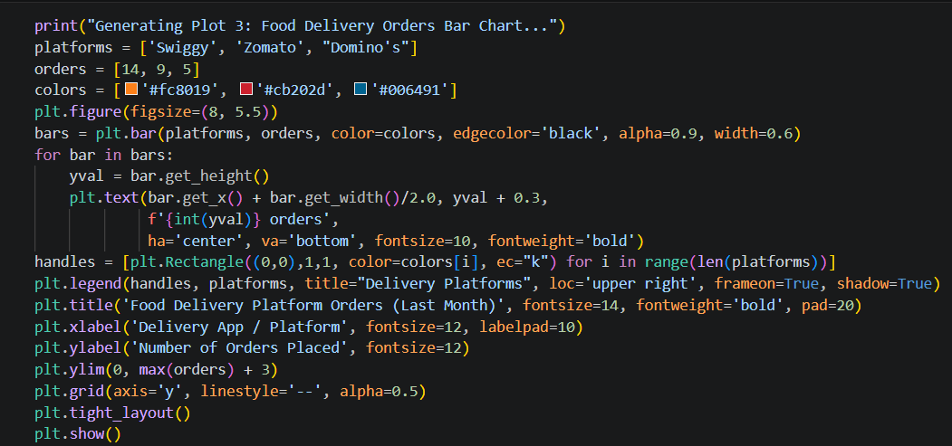
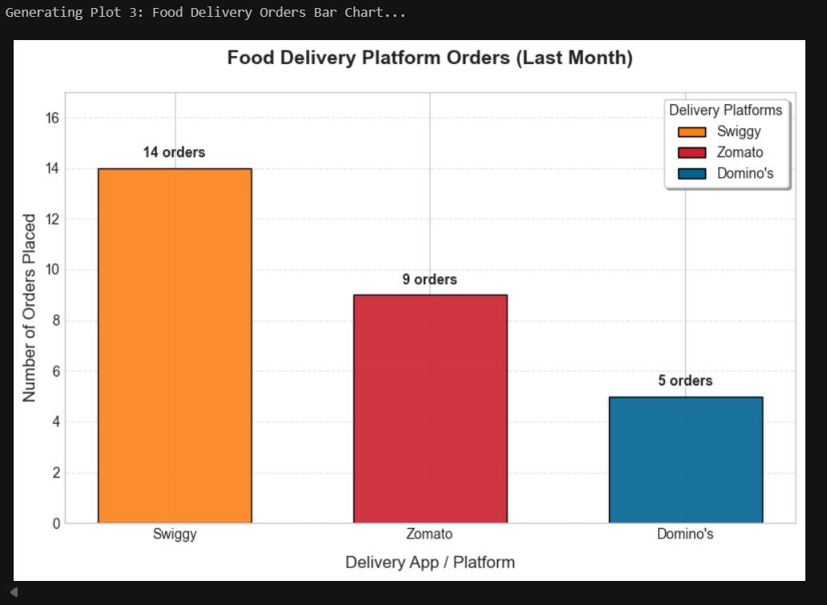

- Create a histogram of the durations (in minutes) of your last 20 Spotify listening sessions using Matplotlib. Set the number of bins to 5 and customize the color of the bars.
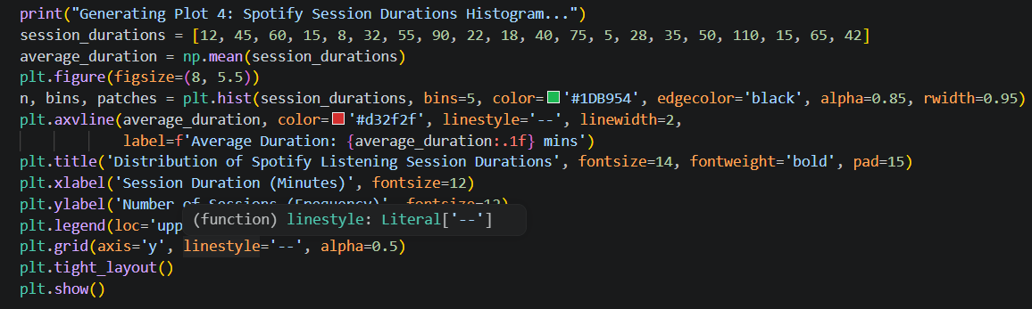
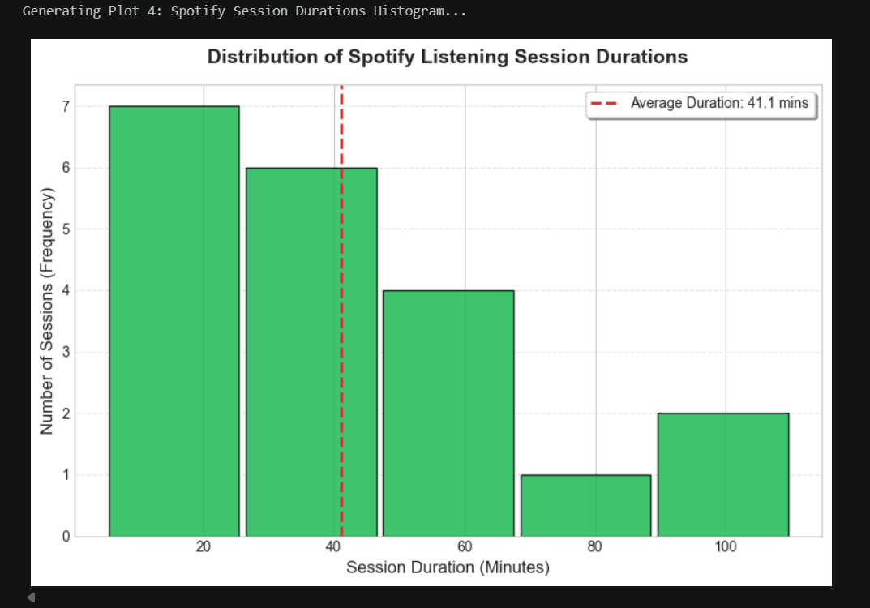

- Customize a Matplotlib figure by creating a plot with two subplots: one line plot showing your daily Instagram screen time for a week, and one bar chart showing the number of posts you liked each day. Add appropriate titles, axis labels, and save the figure as social_media_usage.png. Use plt.subplots() to create multiple axes in one figure.
